5.2.5 Repeated Measures in SPSS

We will demonstrate the equivalent procedure (in SPSS) to PROC MIXED in SAS by analyzing the dental measurements of Pothaff and Roy (1964). The same analysis, using SAS, is presented in 5.2.3.

The procedure can be obtained by going to Analyze > Mixed Models > Linear.

Step 1. In the first screen that appears, specify the subject factor. The subject factor identifies the experimental units on which the measurements are taken. In the dental example, this factor is called person.

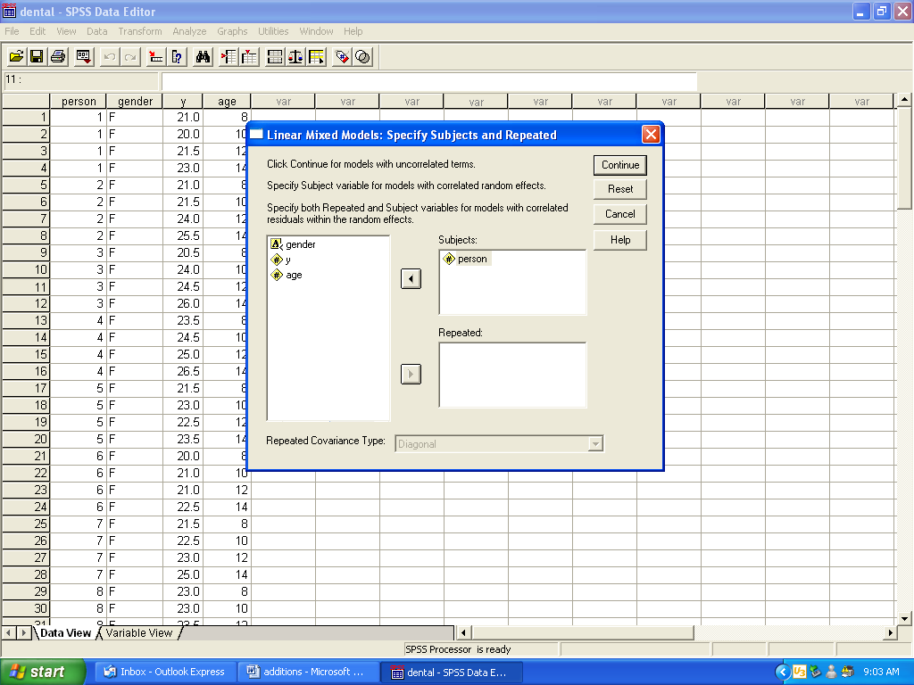

Step 2. Specify the factor that is repeated. The repeated factor is the variable that is used to designate the repeated measurements for each subject. This is the age variable in the dental example, since measurements are taken at 8, 10, 12, and 14 years of age.

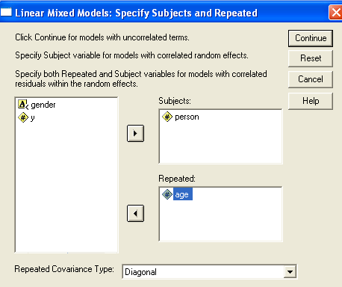

Step 3. Once the repeated factor is specified, the box titled “Repeated Covariance Type” is available. There are several structures available to model the covariance between repeated measurements for a subject. As in the analysis of the dental measurements using SAS’s PROC MIXED, we will choose Compound Symmetry. Click continue.

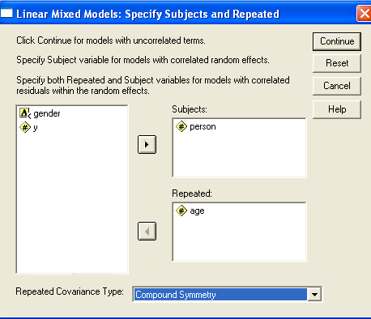

Step 4. The next window is the same window that is used to select the factors for a mixed effects model (demonstrated in 2.2.2). Here, we define the dependent variable and factors. Because both of the factors (gender and age) are fixed, click on the “Fixed” button at the bottom of the window.

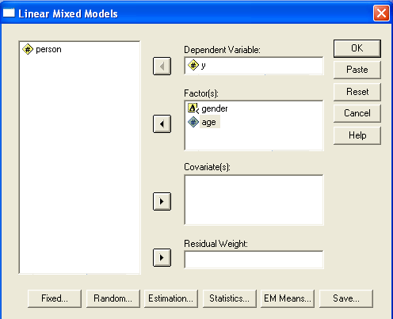

Step 5. Define the fixed factor(s). In our example, both factors are fixed. For a full factorial design, click on the first variable (gender), hold down the shift button on the keyboard, and then click on the next variable (age). Both variables should be highlighted. Then select Factorial from the drop down menu between the two main boxes and click Add. Click Continue and then OK.

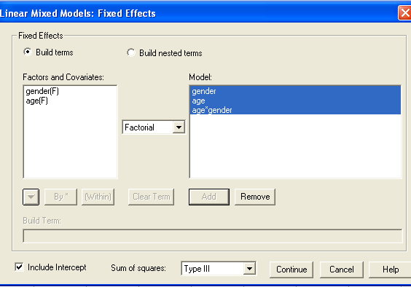

Note: One can request that pairwise comparisons of the means for the fixed factor(s) be displayed by following the steps on page 6 of this manual.

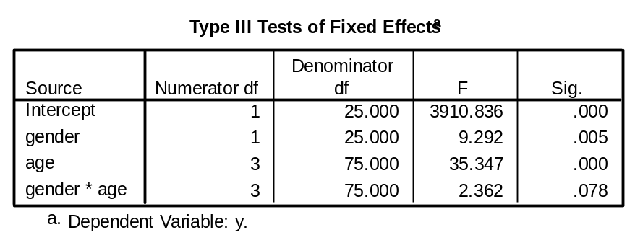
Figure 1. Tests of Fixed Factors

Figure 1 shows that, using, there are differences in gender (p=0.005) and age (p=0.000), but that there is no significant interaction between gender and age (p=0.078).

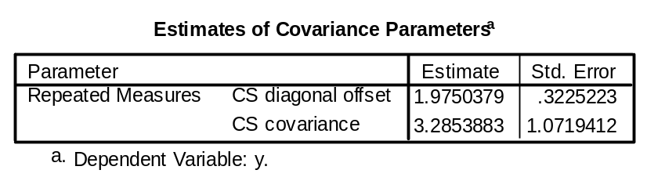
Figure 2. Estimated covariance parameters

Figure 2 presents the estimated covariance parameters. Compound symmetry was used to model the covariance between measurements at different ages. From the table, the variance of the measurements for a subject at a particular age is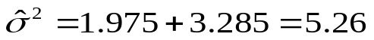 and the covariance between measurements taken at two different ages is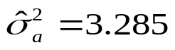. Because we specified compound symmetry as the covariance structure for the repeated measurements, the covariance estimate of 3.285 is the same regardless of the two ages. From these estimates, we can estimate the correlation between measurements taken at different ages. From 5.1.3, the estimate (sometimes known as the intra-class correlation coefficient) is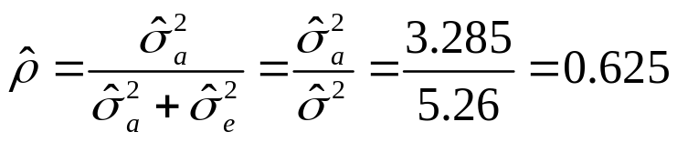.

First Order Autoregressive. To model the covariance between measurements at any two ages, one may decide that a first order autoregressive structure is more appropriate than compound symmetry. As mentioned in 5.1, the first order autoregressive structure, abbreviated as AR(1), has the following form for each subject:

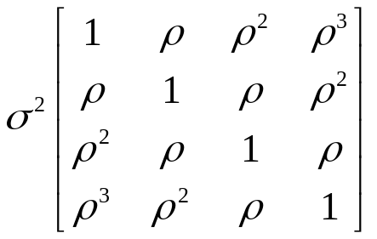, where  is the correlation between measurements taken at successive age levels.

As before, to begin the analysis, go to Analyze > Mixed Models > Linear.

Steps 1 and 2 are the same as before.

Step 3. In the box titled “Repeated Covariance Type”, choose AR(1). Click continue.

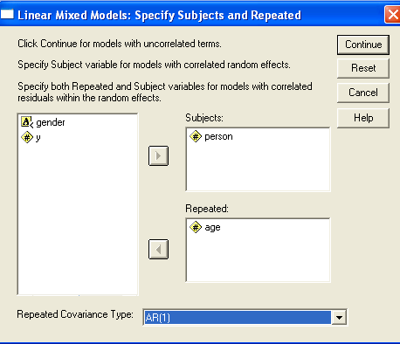

Steps 4 and 5 are the same as before. The following output is obtained.

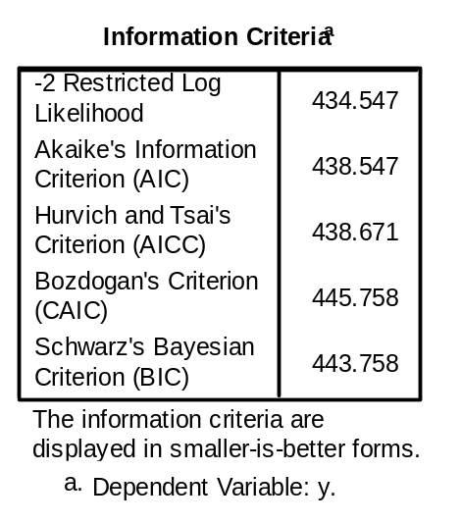
Figure 3. Model fit information

Figure 3 gives several measures of the model fit.
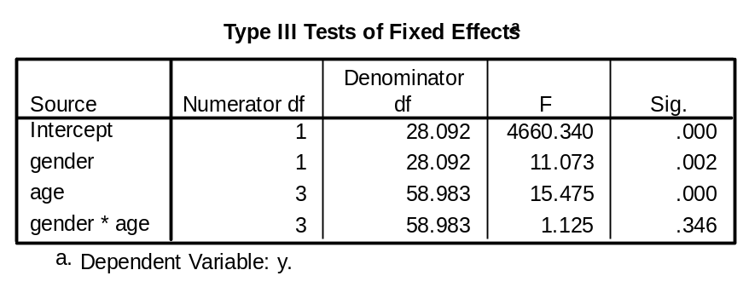
Figure 4. Tests of Fixed Factors

As before, the tests of the fixed effects shows that there are differences in gender (p=0.002) and age (p=0.000). Pairwise comparisons of the levels of these factors should be performed.
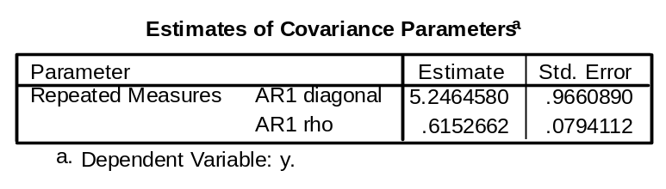
Figure 5. Estimated Covariance Parameters

The estimated variance of the measurements for a subject at a particular age is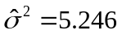. This is given in the row titled “AR1 diagonal”, because it is the entry located on the diagonal of the covariance matrix for a subject (as previously shown). The estimated correlation between successive measurements is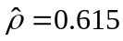. This is given by the entry in the row titled “AR1 rho”. Due to the structure of an AR(1) model, we can estimate the correlation between measurements taken further apart in time, as well. For instance, the estimated correlation between measurements taken on a subject at ages 8 and 12 is 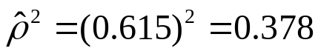, and for measurements taken at ages 8 and 14 is 

